**ALL SPORTS SHOW**

**How to add/edit the front page links?**

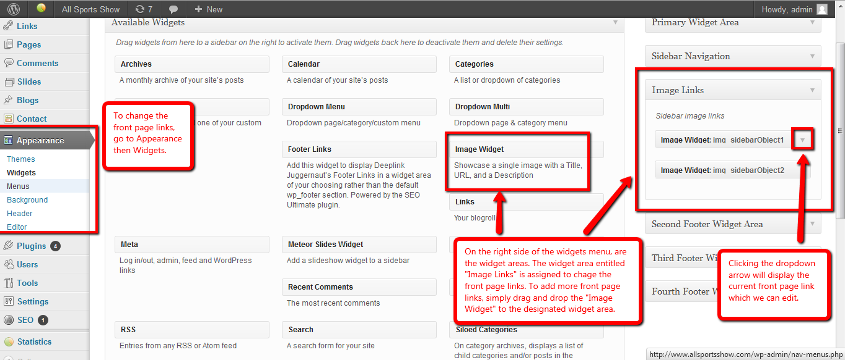

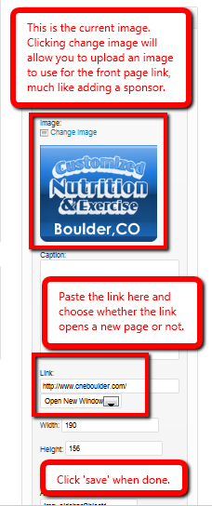

**Blog Information**

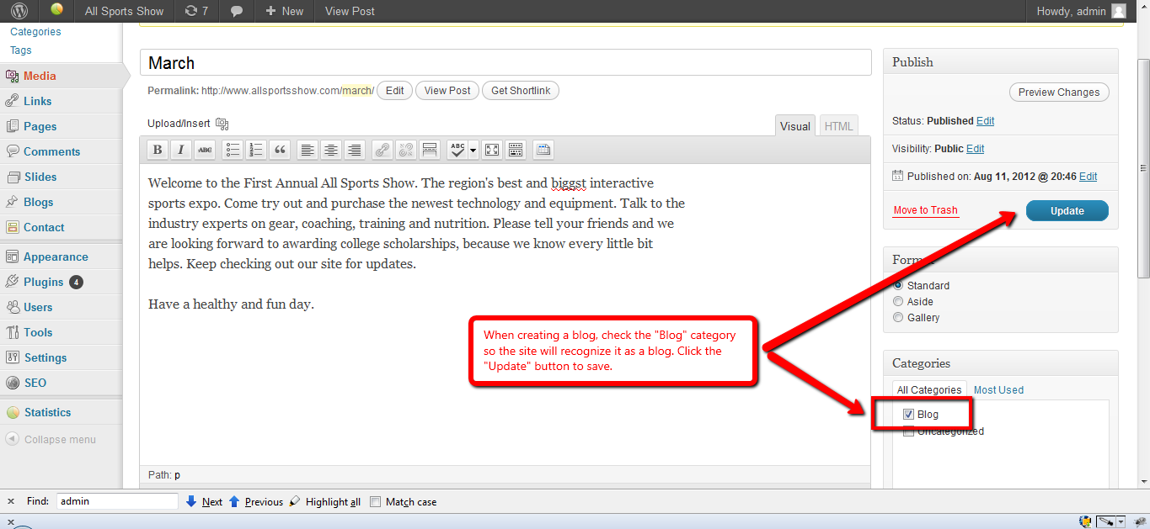

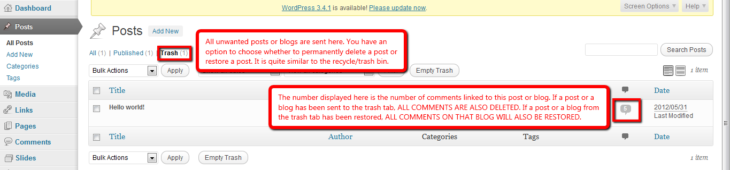

**Viewing Statistics**

